
FURTHER EDUCATION AND TRAINING CERTIFICATE: INFORMATION TECHNOLOGY: SYSTEMS DEVELOPMENT
ID 78965 LEVEL 4 – CREDITS 165
LEARNER GUIDE
SAQA: 9016
REPRESENT ANALYSE AND CALCULATE SHAPE AND MOTION IN 2-AND 3-DIMENSIONAL SPACE IN DIFFERENT CONTEXTS

Learner Information:

Details | Please Complete this Section
Name & Surname:
Organisation:
Unit/Dept:
Facilitator Name:
Date Started:
Date of Completion:

Copyright
All rights reserved. The copyright of this document, its previous editions and any annexures thereto, is protected and expressly reserved. No part of this document may be reproduced, stored in a retrievable system, or transmitted, in any form or by any means, electronic, mechanical, photocopying, recording or otherwise without the prior permission.

Key to Icons
The following icons may be used in this Learner Guide to indicate specific functions:
  Books | This icon means that other books are available for further information on a particular topic/subject.
  References | This icon refers to any examples, handouts, checklists, etc…
  Important | This icon represents important information related to a specific topic or section of the guide.
  Activities | This icon helps you to be prepared for the learning to follow or assist you to demonstrate understanding of module content. Shows transference of knowledge and skill.
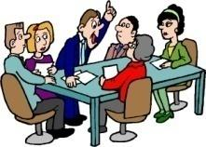  Exercises | This icon represents any exercise to be completed on a specific topic at home by you or in a group.
  Tasks/Projects | An important aspect of the assessment process is proof of competence. This can be achieved by observation or a portfolio of evidence should be submitted in this regard.
  Workplace Activities | An important aspect of learning is through workplace experience. Activities with this icon can only be completed once a learner is in the workplace
  Tips | This icon indicates practical tips you can adopt in the future.
  Notes | This icon represents important notes you must remember as part of the learning process.

Learner Guide Introduction
About the Learner Guide… | This Learner Guide provides a comprehensive overview of the REPRESENT ANALYSE AND CALCULATE SHAPE AND MOTION IN 2-AND 3-DIMENSIONAL SPACE IN DIFFERENT CONTEXTS , and forms part of a series of Learner Guides that have been developed for  The series of Learner Guides are conceptualized in modular’s format and developed for. They are designed to improve the skills and knowledge of learners, and thus enabling them to effectively and efficiently complete specific tasks.  Learners are required to attend training workshops as a group or as specified by their organization. These workshops are presented in modules, and conducted by a qualified facilitator.
Purpose | The purpose of this Learner Guide is to provide learners with the necessary knowledge related to REPRESENT ANALYSE AND CALCULATE SHAPE AND MOTION IN 2-AND 3-DIMENSIONAL SPACE IN DIFFERENT CONTEXTS
Outcomes | At the end of this module, you will be able to:  - Apply knowledge of statistics and probability to critically interrogate and effectively communicate findings on life related problems  - Represent analyse and calculate shape and motion in 2-and 3-dimensional space in different contexts  - Use mathematics to investigate and monitor the financial aspects of personal, business, national and international issues
Assessment Criteria | The only way to establish whether a learner is competent and has accomplished the Learning Outcomes is through an assessment process.  Assessment involves collecting and interpreting evidence about the learner’s ability to perform a task.  This guide may include assessments in the form of activities, assignments, tasks or projects, as well as workplace practical tasks. Learners are required to perform tasks on the job to collect enough and appropriate evidence for their portfolio of evidence, proof signed by their supervisor that the tasks were performed successfully.
To qualify | To qualify and receive credits towards the learning program, a registered assessor will conduct an evaluation and assessment of the learner’s portfolio of evidence and competency
Range of Learning | This describes the situation and circumstance in which competence must be demonstrated and the parameters in which learners operate
Responsibility | The responsibility of learning rest with the learner, so:  - Be proactive and ask questions,  - Seek assistance and help from your facilitators, if required.

Learning Unit1
REPRESENT ANALYSE AND CALCULATE SHAPE AND MOTION IN 2-AND 3-DIMENSIONAL SPACE IN DIFFERENT CONTEXTS
UNIT STANDARD NUMBER : 9016
LEVEL ON THE NQF : 4
CREDITS : 4
FIELD : Physical, Mathematical, Computer and Life
Sciences
SUB FIELD : Mathematical Sciences

PURPOSE: | This unit standard is designed to provide credits towards the mathematical literacy requirements of the NQF at level 4. The essential purposes of the mathematical literacy requirements are that, as the learner progresses with confidence through the levels, the learner will grow in:  •An insightful use of mathematics in the management of the needs of everyday living to become a self-managing person.  •An understanding of mathematical applications that provides insight into the learner`s present and future occupational experiences and so develop into a contributing worker.  •The ability to voice a critical sensitivity to the role of mathematics in a democratic society and so become a participating citizen.  People credited with this unit standard are able to:  •Measure, estimate, and calculate physical quantities in practical situations relevant to the adult with increasing responsibilities in life or the workplace  - Explore analyse and critique, describe and represent, interpret and justify geometrical relationships and conjectures to solve problems in two and three dimensional geometrical situations
LEARNING ASSUMED TO BE IN PLACE:
The credit value is based on the assumption that people starting to learn towards this unit standard are competent in Mathematical Literacy and Communications at NQF level 3

SESSION 1.

MEASURE, ESTIMATE, AND CALCULATE PHYSICAL QUANTITIES IN PRACTICAL SITUATIONS RELEVANT TO THE ADULT

Learning Outcomes
- Scales on the measuring instruments are read correctly.
- Quantities are estimated to a tolerance justified in the context of the need
- The appropriate instrument is chosen to measure a particular quantity.
- Quantities are measured correctly to within the least step of the instrument.
- Appropriate formulae are selected and used.
- Calculations are carried out correctly and the least steps of instruments used are taken into account when reporting final values.
- Symbols and units are used in accordance with SI conventions and as appropriate to the situation.

Measurements for most are a big part of our daily lives. Along every step of the way we are able to notice things which require measurement of some sort. Let’s have a look how measurement affects us:
Measurements can be found in just about everything. Let’s see if you can identify what type of measurement is used and / or required in the following situations:
- When you buy groceries and need to work out whether you have sufficient funds.
Measurement:

- When you calculate how much ingredients you will need to prepare the meal.
Measurement:

- When you work out how much overtime you have worked for a particular month.
Measurement:
- When you work out how much discount you are able to offer your client.
Measurement:

- When you determine the correct setting on the oven during baking.
Measurement:

- When you calculate how far it is that you will need to travel.
Measurement:

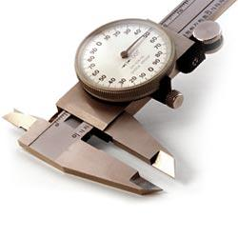

ACTIVITY - BRAINSTORM
Brainstorm in your groups what other forms of measurements are found in both your everyday work situations and personal lives. List your responses below:
EVERYDAY WORK SITUATIONS | EVERYDAY PERSONAL LIVES

Can you identify what measurements are measured with the following instruments and also indicate in what quantities each instrument would measure? Write your answers next to each picture below:
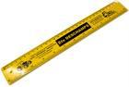
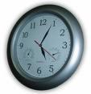
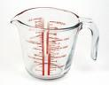
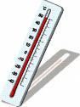
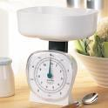
Making use of formulae to calculate measurements
The use of formulae’s to calculate measurements allow us to complete the calculation quicker and easier. The formulae provide us with set rules which we could follow to ensure that our calculation remains accurate and correct.
Let’s have a look at a simple example to help us understand this concept.
Finding Hours and Minutes
Formulae Purpose: How to find hours and minutes when the number of minutes is known.
Formulae:
- Divide the number of minutes by 60.
- The quotient is the number of hours.
- The remainder is the number of minutes greater than those in full hours.
Example:
If you have 240 free talk-time minutes on your cellular contract every month, you can use the above formulae are as follows:
- 240 minutes divide by 60 equals: 4 hours

Conclusion: You have 4 hours of free talk-time minutes every month to make use of.
activity – examples of other formulae’s
Now give another two examples of formulae’s that you can make use of. Give examples to explain your answers. Record them below:
Formulae Purpose:

Formulae:

Example:

Formulae Purpose:

Formulae:

Example:

SESSION 2.

EXPLORE, ANALYSE & CRITIQUE, DESCRIBE & REPRESENT, INTERPRET AND JUSTIFY GEOMETRICAL RELATIONSHIPS

Learning Outcomes
- Descriptions are based on a systematic analysis of the shapes and reflect the properties of the shapes accurately, clearly and completely.
- Descriptions include quantitative information appropriate to the situation and need.
- 3-dimensional objects are represented by top, front and side views.
- Different views are correctly assimilated to describe 3-dimensional objects.
- Available and appropriate technology is used in producing and analysing representations.
- Relations of distance and positions between objects are analysed from different views.
- Conjectures as appropriate to the situation, are based on well-planned investigations of geometrical properties.
- Representations of the problems are consistent with and appropriate to the problem context. The problems are represented comprehensively and in mathematical terms.
- Results are achieved through efficient and correct analysis and manipulation of representations.
- Problem-solving methods are presented clearly, logically and in mathematical terms.
- Reflections on the chosen problem solving strategy reveal strengths and weaknesses of the strategy.
- Alternative strategies to obtain the solution are identified and compared in terms of appropriateness and effectiveness.

Using and Analysing Shape and geometrical relationships
The ability of analysing and understanding shapes and figures allows us to make calculated decisions about everyday life when faced with certain situations. Shapes and figures have geometrical relationships which act as “formulae” and solutions to complex problems. Shapes might have equal sides, which mean that the measurement of those two equal sides will be the same.
Remember:
- Shape can take the form of distance over land and curves on a soccer ball. It is not always just considered as a particular figure of an object.
now let’s have a look at a practical example
Problem situation:
If you travel from point A to point B and the distance from one point to the other is 5 km. What will the total distance be which needs to be travelled if one needs to go there and come back 5 times a day over 2 weeks?
Notes:
- The distance from point A to point B is 5km. The return distance will also be 5km, therefore totalling 10km.
- If the above distance of 10km per travel needs to be completed 5 times a day it would equal 50km a day.
- 50km a day worth of travelling over two weeks (14 days) will equal:
Total Distance: 700 km
Have a look at the picture below and answer the questions that follow by circling the correct answer/s:
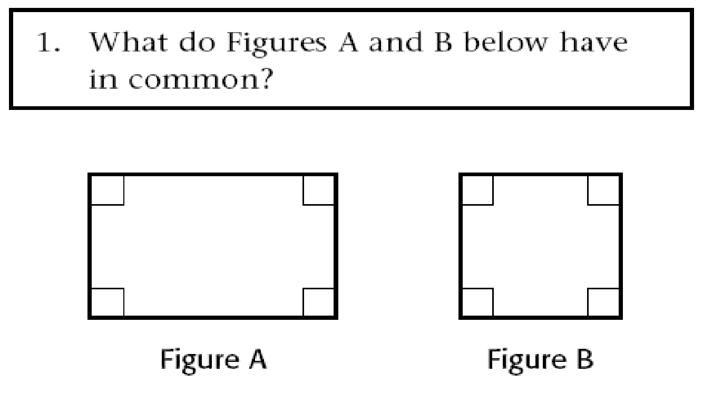

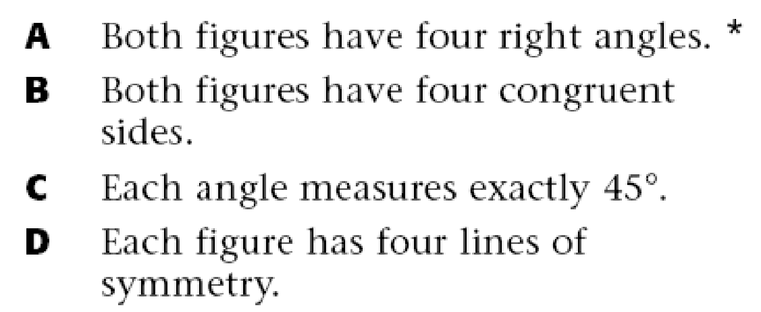

Question:
- In your own words, explain what the geometrical relationship is between the two shapes above.
now let’s have a look at a practical example

Problem situation:
If you travel from point A to point B and the distance from one point to the other is 5 km. What will the total distance be which needs to be travelled if one needs to go there and come back 5 times a day over 2 weeks?
Notes:
- The distance from point A to point B is 5km. The return distance will also be 5km, therefore totalling 10km.
- If the above distance of 10km per travel needs to be completed 5 times a day it would equal 50km a day.
- 50km a day worth of travelling over two weeks (14 days) will equal:
Total Distance: 700 km
Can you think of similar everyday problems which could be solved by using their geometrical relationship?
Write your example below:

